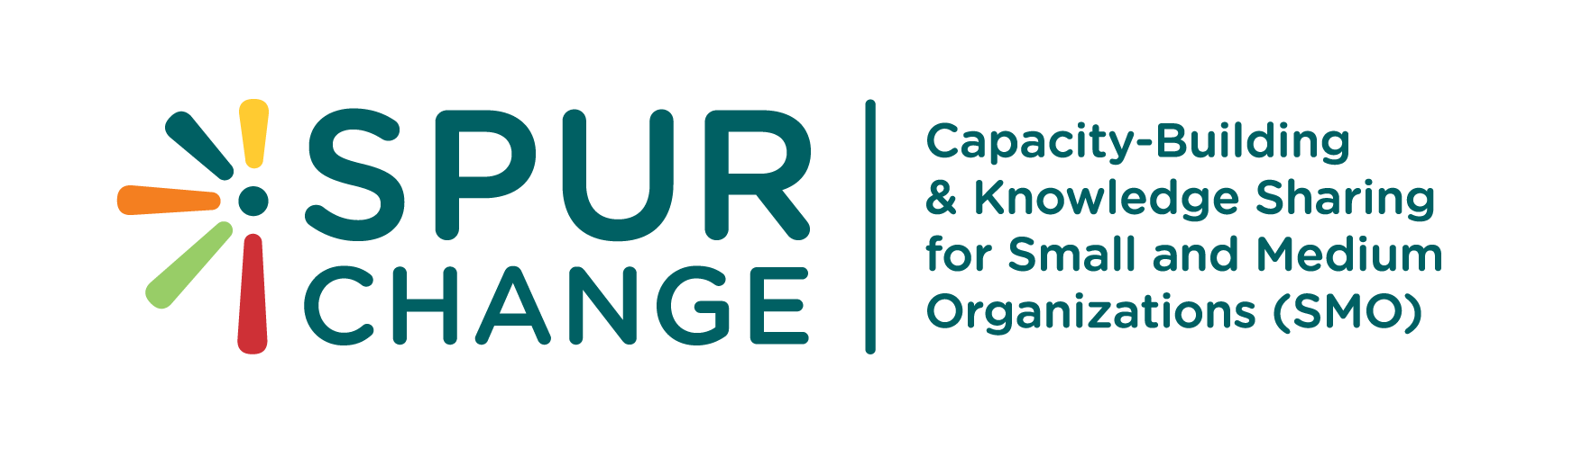
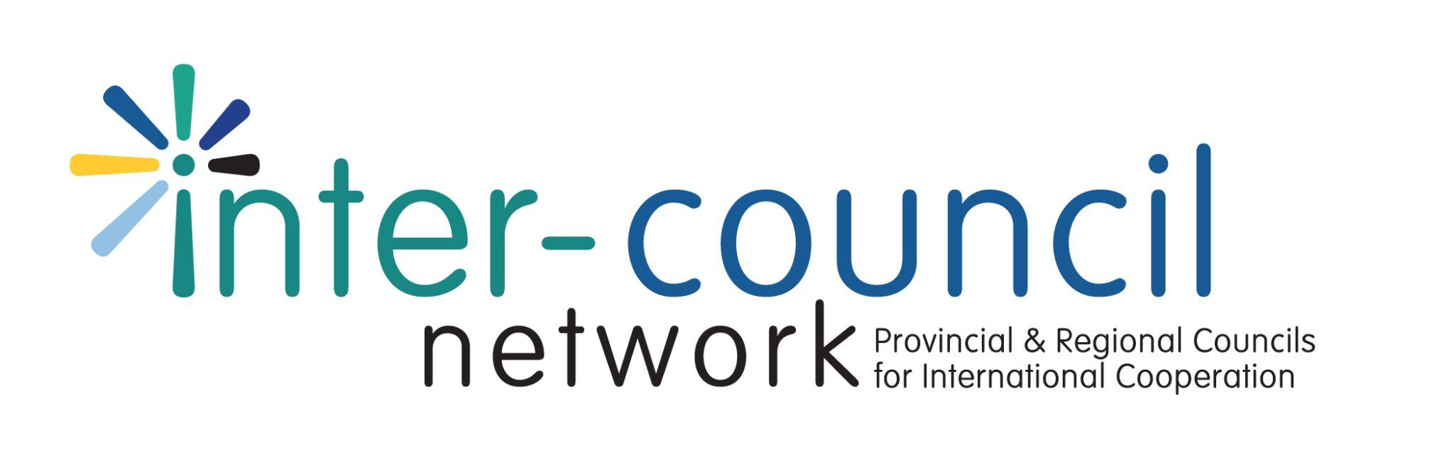
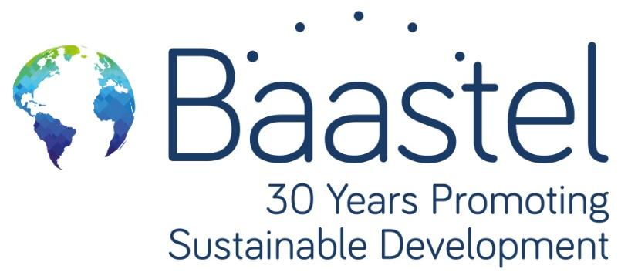


RESULTS – BASED MANAGEMENT 201
Participant Worksheets

January 2022
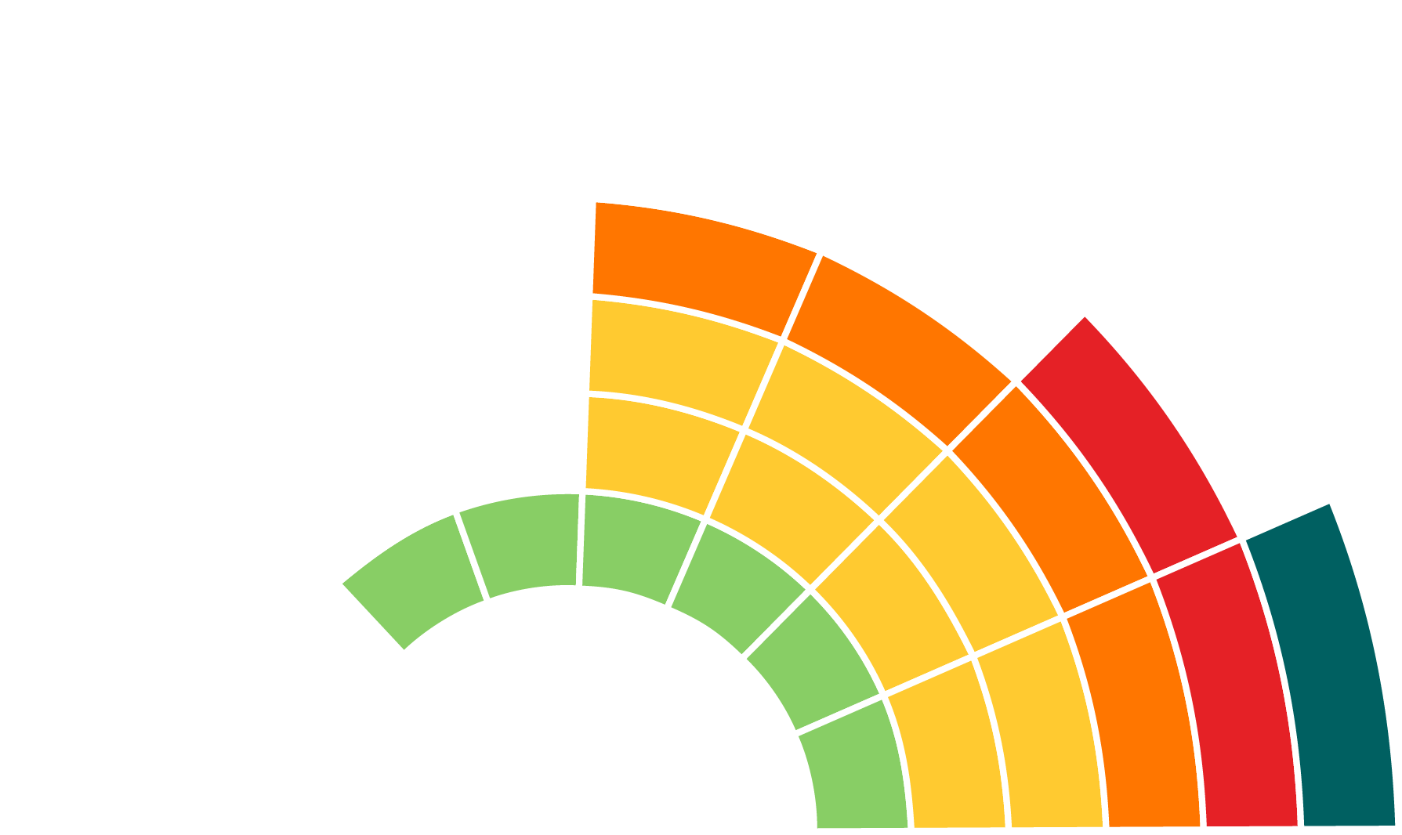
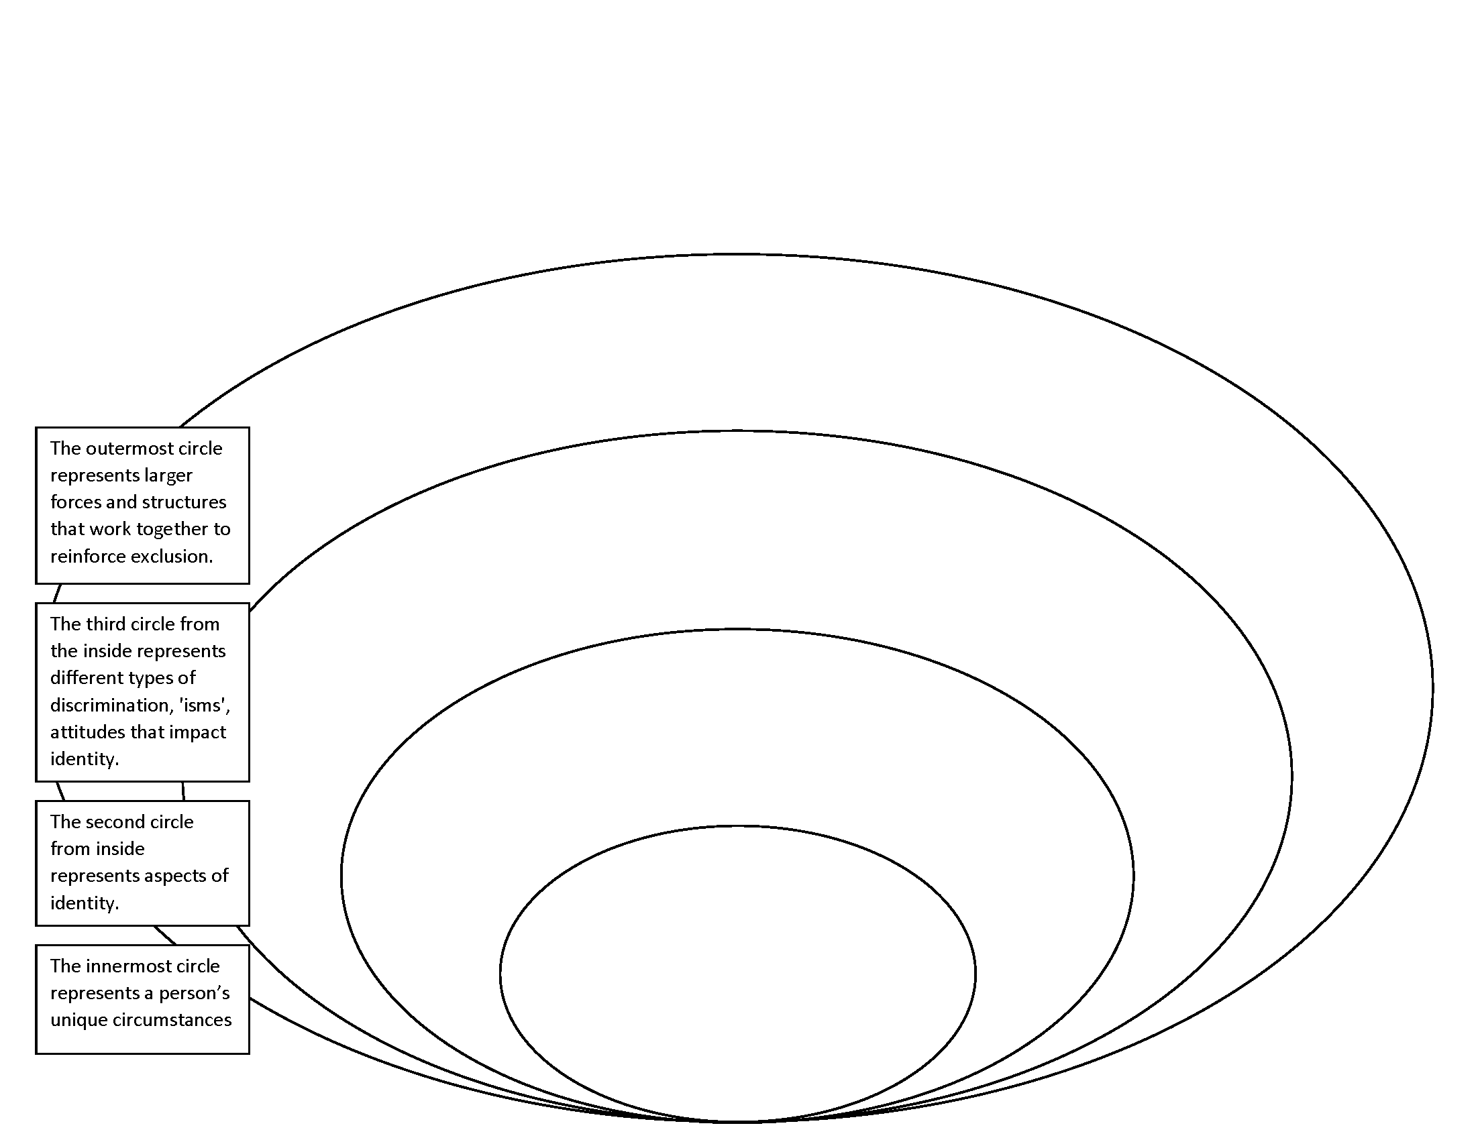
Using the case study in the Participant Activity Book (page 4) conduct a situational analysis. Further instructions for each analysis are available in the Participant Activity Book (pages 4-8).

Activity 1.a. Situational Analysis: GE & Intersectional Analysis
Fill in the template provided using the “Text box” or “Shapes” feature found under the Insert tab.

Activity 1.b. Situational Analysis: SWOT Analysis
Using the same case study conduct a situational analysis by filling in the template provided. Brainstorm as many relevant strengths, weaknesses, opportunities and challenges as possible.
Fill in the template provided by typing directly in the table.

STRENGTHS | WEAKNESSES
OPPORTUNITIES | CHALLENGES

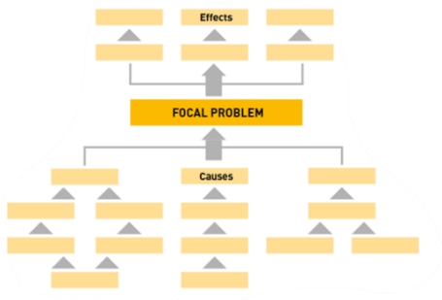
Activity 1.c. Situational Analysis: Problem Tree
Brainstorm as many relevant strengths, weaknesses, opportunities and challenges as possible. Work on mapping out the focal problem the project is looking to address, as well as the underlying reasons behind the focal problem and its consequences.
Fill in the template provided using the “Text box” or “Shapes” feature found under the Insert tab.
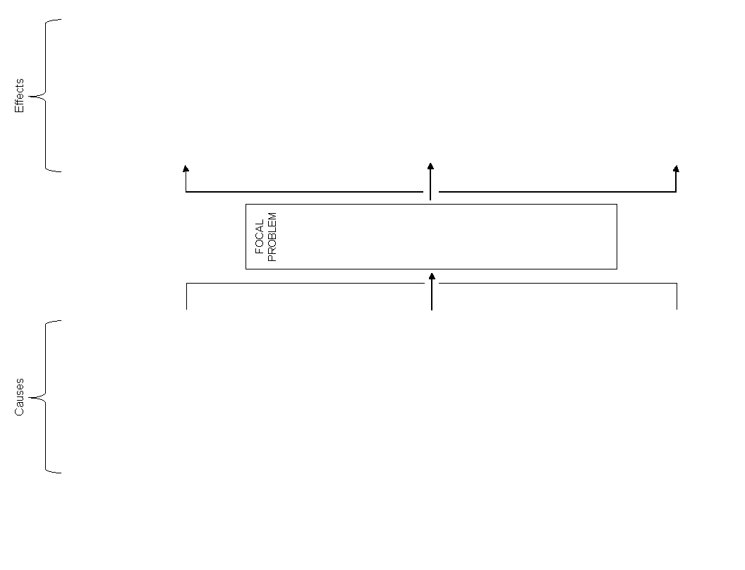

Activity 2. Building a Theory of Change
Develop a ToC for the case study (Activity Book page 4).
A theory of change focuses on the impact of an intervention What has changed as a result of your direct intervention? For whom? How significant is it for them? Will it last? Why or why not? What if anything, did our efforts lead to? Focus on the cause and effect relationships between the actions of the intervention and the results.
Risks and Assumptions:
Fill in the template provided by selecting the blank rectangles and beginning to type.
Note: this is just one way of graphically representing a ToC. They can take many forms--be it in a graphic or a narrative format.

Activity 3.a. Logic Model Puzzle
17. $2 million responsive innovation fund developed & implemented for governmental programming innovations that support enterprise development
Rebuild the Logic Model in the correct order, checking assumptions
13. Technical Assistance provided to regional economic developmental support facility to consult on & provide gender responsive info to enterprises
9.Technical assistance provided to economic stakeholders to strengthen consultation mechanisms on inclusive & gender responsive economic development plans
and analyzing the cause and effect relationships between outputs,
immediate, intermediate and ultimate results.
Hold and drag the squares to rearrange the puzzle.
(Answer key is found on page 9.)
4.Technical assistance provided to government to identify & address key constraint, including gender-based barriers in business regulation and licensing
8.Improved ability of government to address key constraints in business regulations and licensing that impede gender-responsive economic growth
11. Increased access by enterprises to gender-responsive business development services
3.Technical assistance provided to government for the resolution of selected national legal & regulatory issues, including gender inequality & impeding economic growth
16. Technical assistance provided to the economic development support facility to develop and use gender responsive economic development support tools
7.Increased employment and incomes for poor women and men in Indonesia
2.TA provided to regional economic development coordination team, ministries, & sectoral units to coordinate & facilitate gender responsive program implementation
1.Increased capacity of local governments and enterprises to coordinate activities and sustainably connect and integrate into the regional and national economy
12. Strengthened gender-sensitive climate investment
15. Technical assistance provided to economic stakeholders to facilitate regional cooperation for economic development
6.Improved ability of national agencies to support equitable local and regional economic development
5.More sustainable, equitable and competitive enterprises
14. TA provided to government and NGO service providers to develop & deliver gender responsive services to enterprises to enhance competitiveness within sub-sectors
10.TA provided to economic stakeholders to conduct gender responsive economic analysis & to sub-sectors with potential for inclusive growth & innovation
Activity 3.b. Building a Logic Model
Apply your knowledge to draft a logic model for the case study. When developing a LM be sure to consider the risks and assumptions that underpin and could affect your program. Review the situational analysis exercises (Activity 1) to understand the context of your project design.
Fill in the template by selecting and typing directly in the diagram.
Activity 4.a. PMF Puzzle
Reconstruct this PMF puzzle. Keep in mind both the vertical and horizontal relations of each piece.
Hold and drag the squares to rearrange the puzzle. (Answer key is found on page 10.)
Expected Results | Indicator | Baseline | Targets | Data Sources | Methods | Frequency | Responsibility
Knowledge exchange and capacity development products and events completed  Analytical tools and methods developed  % of stakeholders reporting awareness of CIHI products & services  External evaluator & project M&E Staff  Extent to which CIHI has contributed to pan-Canadian health system improvements  % of planned health information infrastructure enhancements completed within the year  Increased use of Canadian Institute for Health Information ’s products and services to support decision-making | % of stakeholders who report using evidence from a CIHI knowledge product or service to support decision-making  project M&E Staff  # of users of CIHI’s private online tools/products  Annually  Document review  Improved Pan-Canadian population health systems  project M&E Staff | 0% of planned health information infrastructure enhancements completed  project M&E Staff  project M&E Staff  0 users of CIHI’s private online tools/products  10% of planned new and enhanced analytical tools completed by CIHI  CIHI has contributed to a low extent to pan-Canadian health system improvements  10% of stakeholders report using evidence from a CIHI knowledge product or service to support decision-making | 75% of stakeholders report using evidence from a CIHI knowledge product or service to support decision-making  75% of planned health information infrastructure enhancements completed  0 knowledge exchange and capacity development products and events  1000 users of CIHI’s private online tools/products  Stakeholders  10% of stakeholders reporting awareness of CIHI products & services  Annually | 8 Knowledge exchange and capacity development products and events completed  Administrative data  Administrative data & attendance sheets  Health information infrastructure enhanced  CIHI has contributed to a high extent to pan-Canadian health system improvements  Case study & Stakeholders  Stakeholders | Google Analytics  project M&E Staff  Google Analytics reports  Surveys  Document review  External evaluation  Administrative data | Document review  Annually  Surveys  75% of stakeholders reporting awareness of CIHI products & services  Increased stakeholder knowledge of CIHI products and services  Increased access to analytical tools and products  project M&E Staff | Quarterly  Number and type of knowledge exchange and capacity development products and events  % of new and enhanced analytical tools completed by CIHI  100% planned new and enhanced analytical tools completed by CIHI  Project Closure  Annually  Quarterly

Activity 4.b PMF Building
Develop a PMF for the logic models developed in Activity 3.b for the project, Building Community Resilience to Climate Change in Senegal.
Fill in the template provided by typing directly in the table.
Expected Results | Indicator | Baseline | Target | Data Sources | Methods | Frequency | Responsibility
Ultimate Outcome
Intermediate Outcomes
Immediate Outcomes
Outputs

Answer Key: Activity 3.a. Logic Model Puzzle
1.Increased capacity of local governments and enterprises to coordinate activities and sustainably connect and integrate into the regional and national economy
9.Technical assistance provided to economic stakeholders to strengthen consultation mechanisms on inclusive & gender responsive economic development plans
6.Improved ability of national agencies to support equitable local and regional economic development
8.Improved ability of government to address key constraints in business regulations and licensing that impede gender-responsive economic growth
13. Technical Assistance provided to regional economic developmental support facility to consult on & provide gender responsive info to enterprises
12. Strengthened gender-sensitive climate investment
16. Technical assistance provided to the economic development support facility to develop and use gender responsive economic development support tools
14. TA provided to government and NGO service providers to develop & deliver gender responsive services to enterprises to enhance competitiveness within sub-sectors
11. Increased access by enterprises to gender-responsive business development services
7.Increased employment and incomes for poor women and men in Indonesia
10.TA provided to economic stakeholders to conduct gender responsive economic analysis & to sub-sectors with potential for inclusive growth & innovation
4.Technical assistance provided to government to identify & address key constraint, including gender-based barriers in business regulation and licensing
17. $2 million responsive innovation fund developed & implemented for governmental programming innovations that support enterprise development
15. Technical assistance provided to economic stakeholders to facilitate regional cooperation for economic development
3.Technical assistance provided to government for the resolution of selected national legal & regulatory issues, including gender inequality & impeding economic growth
5.More sustainable, equitable and competitive enterprises
2.TA provided to regional economic development coordination team, ministries, & sectoral units to coordinate & facilitate gender responsive program implementation
Answer Key: Activity 4.a. PMF Puzzle

Expected Results | Indicator | Baseline | Targets | Data Sources | Methods | Frequency | Responsibility
% of planned health information infrastructure enhancements completed within the year
Increased use of Canadian Institute for Health Information ’s products and services to support decision-making
10% of stakeholders reporting awareness of CIHI products & services
10% of stakeholders report using evidence from a CIHI knowledge product or service to support decision-making
% of stakeholders who report using evidence from a CIHI knowledge product or service to support decision-making
0% of planned health information infrastructure enhancements completed
8 Knowledge exchange and capacity development products and events completed
75% of stakeholders report using evidence from a CIHI knowledge product or service to support decision-making
75% of planned health information infrastructure enhancements completed
CIHI has contributed to a low extent to pan-Canadian health system improvements
10% of planned new and enhanced analytical tools completed by CIHI
0 users of CIHI’s private online tools/products
Stakeholders
1000 users of CIHI’s private online tools/products
0 knowledge exchange and capacity development products and events
Improved Pan-canadian population health systems
Annually
Document review
# of users of CIHI’s private online tools/products
project M&E Staff
Knowledge exchange and capacity development products and events completed
Analytical tools and methods developed
External evaluator & project M&E Staff
Extent to which CIHI has contributed to pan-Canadian health system improvements
project M&E Staff
project M&E Staff
project M&E Staff
project M&E Staff
project M&E Staff
Annually
Google Analytics
CIHI has contributed to a high extent to pan-Canadian health system improvements
Health information infrastructure enhanced
Administrative data & attendance sheets
Administrative data
Stakeholders
Case study & Stakeholders
100% planned new and enhanced analytical tools completed by CIHI
75% of stakeholders reporting awareness of CIHI products & services
Increased stakeholder knowledge of CIHI products and services
Increased access to analytical tools and products
Google Analytics reports
Surveys
External evaluation
Administrative data
Document review
Document review
Surveys
Annually
Annually
Quarterly
Quarterly
Project Closure
% of stakeholders reporting awareness of CIHI products & services
% of new and enhanced analytical tools completed by CIHI
Number and type of knowledge exchange and capacity development products and events



